**Performance & Final Submission Phase**

|  |  |
| --- | --- |
| Date | 13-November-2023 |
| Team ID | E33B9708C8C449FB8CB4AC7247F2508D |
| Project Name | Build and Email Campaign: Create a brand launch email – Using Mailchimp |

**Model Performance Metrics**

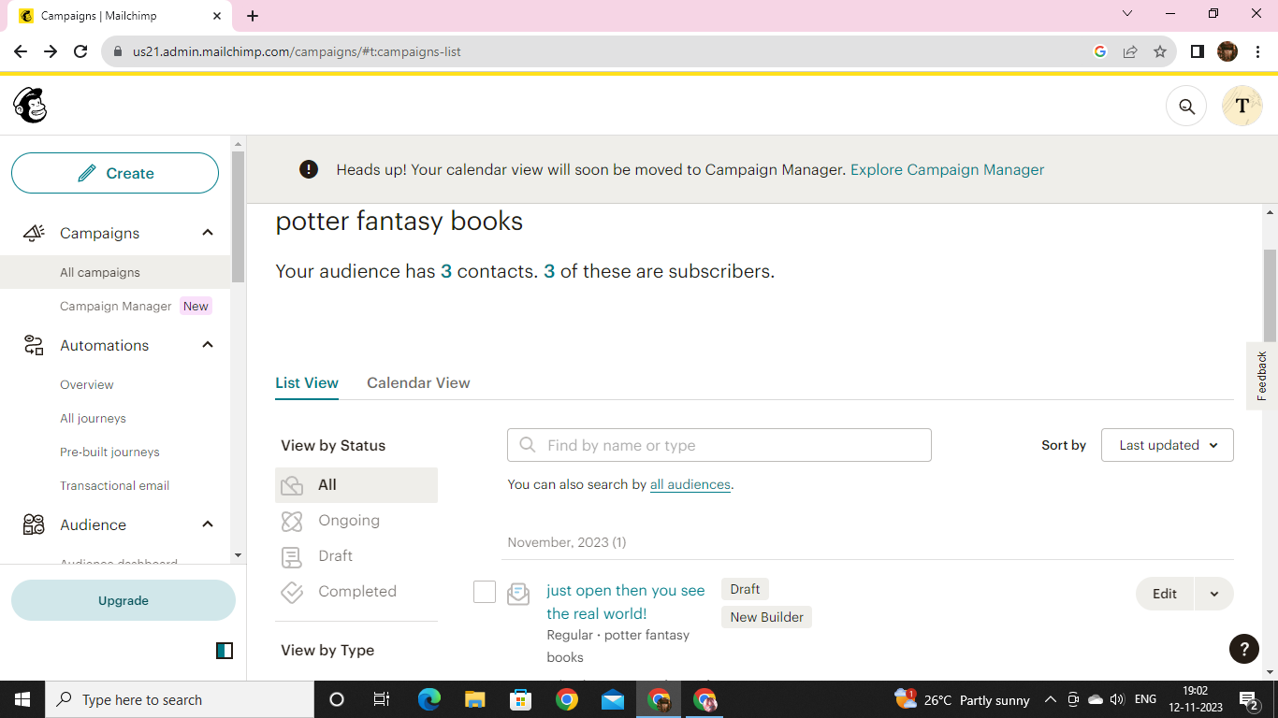

**Mailchimp link:**

[**https://us21.admin.mailchimp.com/email/editor?id=12662168**](https://us21.admin.mailchimp.com/email/editor?id=12662168)

**2) Project Documentation**

Documentation – With attached screenshots for steps.

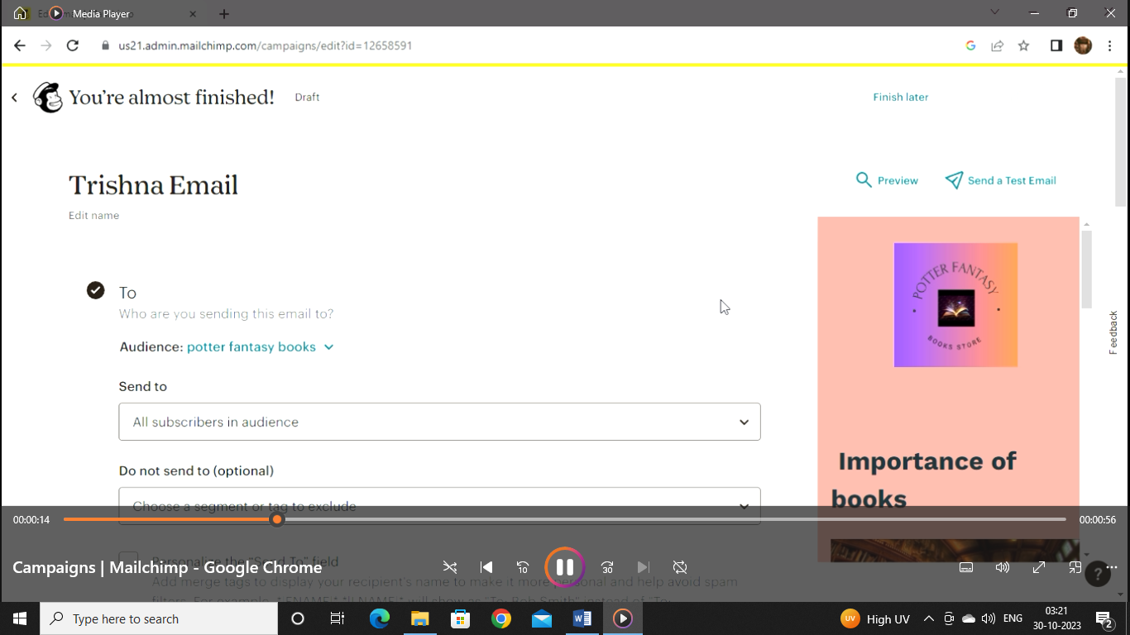

Step 1: Fill the to content (recipients)

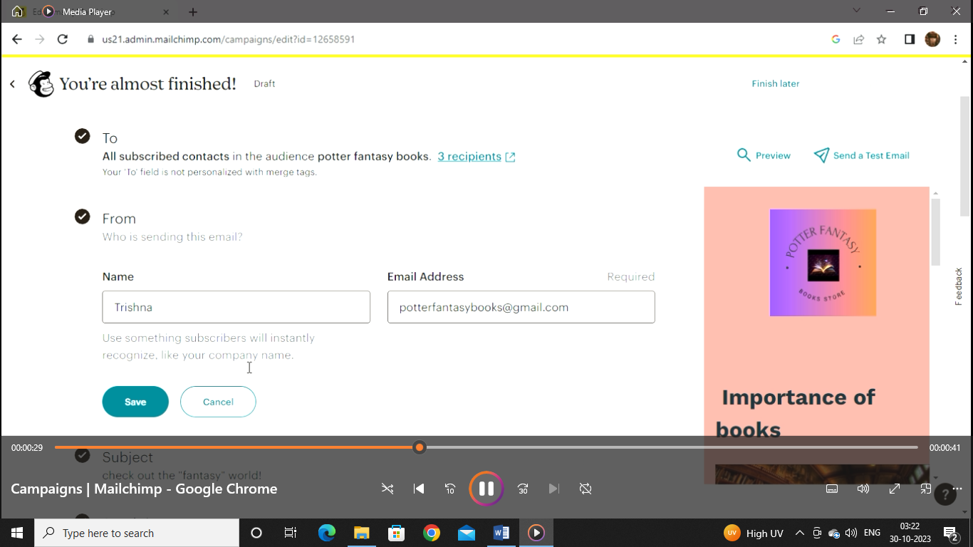

Step 2: Fill the from content

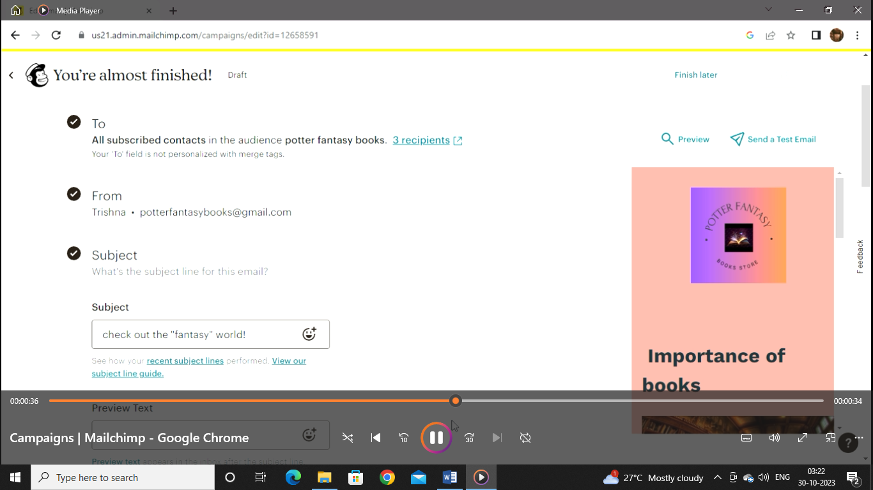

Step 3: Fill the subject content

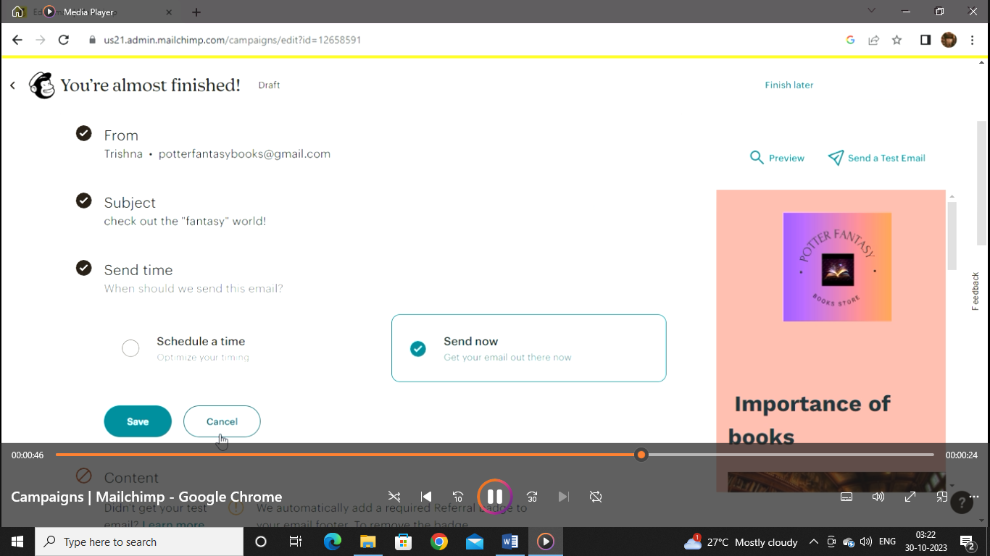

Step 4: Fill the sent time

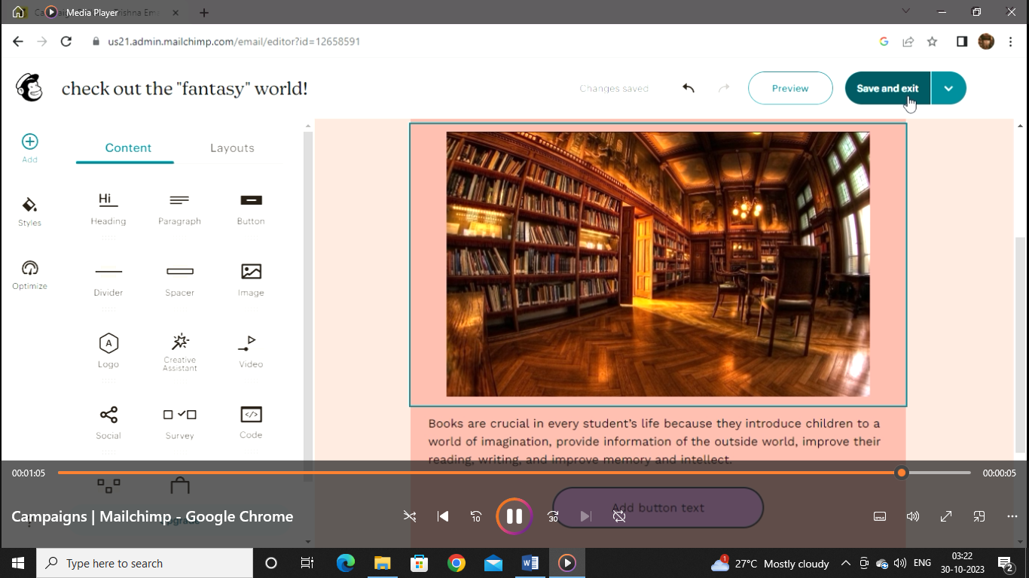

Step 5: Create the template

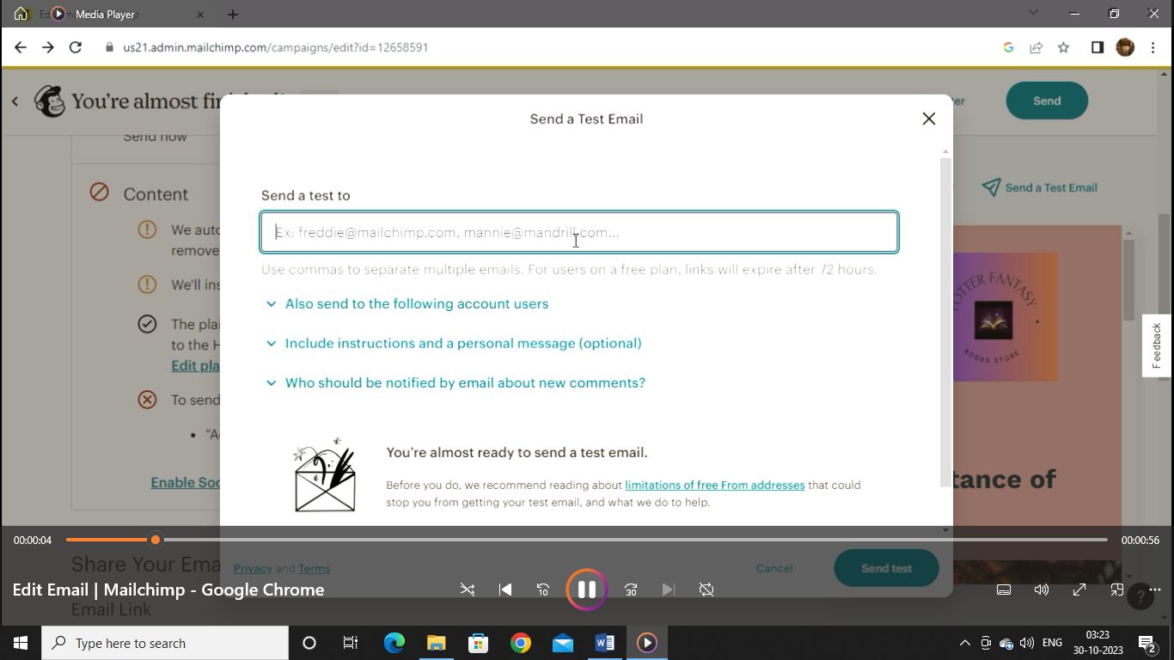

Step 6: Send the test email

**3) Project Demonstration**

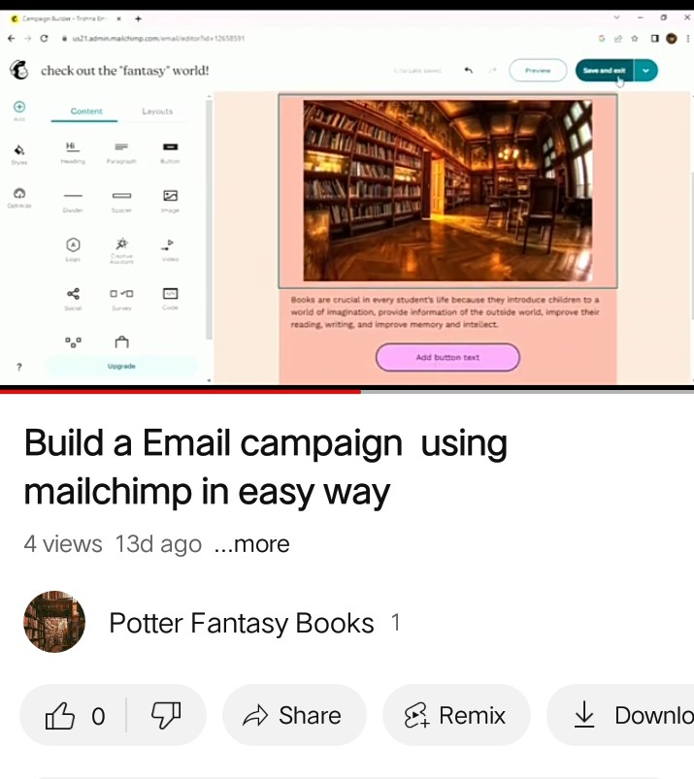

YouTube link:

<https://youtu.be/9akWeq_LwJ8?si=GzDlQeDeHq2WadBv>